"Encoding Queer Erasure in Oscar Wilde’s

‘The Picture of Dorian Gray’ (1890).

Filipa Calado

## Introduction

Textual scholars have long speculated over Wilde's intentions as he wrote and revised his famous novel, The Picture of Dorian Gray (1891). Among the more striking changes to the manuscript (MS) version of the story is the suppression of homoeroticism between the three main characters: the painter Basil Hallward, his subject Dorian Gray, and their friend, Lord Henry Wotton. Scholars generally posit that Wilde's treatment of the homoerotic elements could be part of a larger project of "modernizing" the text, which is achieved by transforming the protagonist, Dorian Gray, into an aesthetic rather than erotic object in the story.

My project examines in detail Wilde's revisions to the manuscript's homoerotic elements by using a digital tool that allows researchers to mark and describe each change in the manuscript. I follow the electronic editing standard called the Text Encoding Initiative (TEI) to encode or "mark up" the changes that Wilde made on the first chapter of this text. Text encoding with TEI (as explained further below) allows researchers to isolate and describe in detail various features of textual data, in my case, the deletions and additions that Wilde made on his manuscript. In analyzing these changes, I draw from debates in Textual Scholarship and Queer Historiography, which inform my approach for handling homoerotic subject matter within digital contexts. I find that these debates interestingly probe the question of how textual scholarship in Queer Studies might restore or "rescue" literary material and queer subjects from the past.

This project endeavours to answer a question that plagues the emerging field of Queer Digital Humanities, or "Queer DH." As TEI and Literary Scholar Julia Flanders asks--do we need to queer markup or is markup already queerable? Flanders questions markup's place between two current approaches in Queer DH: first, the approach that wants to disrupt formal systems by imagining alternative ones;[1] and second, the approach in which queerness is built into computing, is inherent in computational logic.[2] I end with proposing a method for electronic editing that marks Wilde's alterations and deletions in TEI formal language to explore this question of TEI's queerability. My method examines how TEI might work within a queer ethos as a tool of containment for speculative analysis by enclosing and fixing homoerotic elements in text.

## Textual Scholarship

Before proceeding with the content of Wilde's manuscript, I will give a general overview of editorial approaches in the field of Textual Scholarship. Dominant editorial practices increasingly delimit the purpose and purview of the editor as a recoverer or preserver of texts, while other perspectives permit the authority of the editor as an enabler of textual readings. The history of Textual Criticism thus presents an arc, which first tends toward what I call the "restorative approach" then, spurred by the advent of digital technology, the "productive approach." As I review the different approaches, I emphasize how the productive capacity functions within textual editing paradigm. Aided by the popularization of digital tools, editing becomes less about "correcting" or aligning text with a prior witness, and more about finding ways to multiply the text's potential forms and readings.

The "restorative approach" begins with the work of Ronald B. McKerrow, a leading twentieth-century Shakespearean scholar, who maintains that the goal of scholarly editing is to preserve authorial intention. McKerrow's influential model for "copy-text" editing, which establishes the base text for editing (the "copy-text") on an early witness that most closely resembles the author's original intention, eventually creates resistance among textual scholars who decry the "the tyranny of the copy-text." To address these concerns, Walter W. Greg's The Rationale of Copy-Text expands critics' purview to other witnesses that may contain substantive changes by the author. Fredson Bowers and Thomas Tanselle advance Greg's work, emphasizing the importance of authorial intention in the "Greg-Bowers-Tanselle method." Their method favours the "eclectic edition," which draws from multiple sources and depends heavily on the editor's judgment to determine authorial intention in each source. Tanselle places much value in the editor who, according to Tanselle, is the only one able to recognize and manage inevitable textual corruption. In the below passage, Tanselle describes the physical "text" as a vessel for the ideal "work" that can only be realized by the editor:

Those who believe that they can analyse a literary work without questioning the constitution of a particular written or oral text of it are behaving as if the work were directly accessible on paper or in sound waves… its medium is neither visual nor auditory. The medium of literature is the words (whether already existent or newly created) of a language; and arrangements of words according to the syntax of some language (along with such aids to their interpretation as pauses or punctuation) can exist in the mind, whether or not they are reported by voice or in writing. 16-17

Tanselle explains that act of inscription involves physical tools that ultimately corrupt the pure ideas "in the mind" of the writer. In order to realize the ideal form of her text, therefore, the writer requires an editor who remains sufficiently distant from the creation and transcription of the text to objectively intimate its true intention.

Toward the end of the 20th century, some textual critics take an opposing perspective on the effect of inscription and tools on the textual material. D.F. McKenzie, in particular, in his ground-breaking work, Bibliography and the Sociology of Texts (1999), examines how the materiality of texts, which include sound and electronic media, takes on new forms and meanings in in their reprinting and reproduction. McKenzie traces what he calls the "sociology" of texts by studying the social context that produced each witness. He points out that "Every society rewrites its past, every reader rewrites its texts, and if they have any continuing life at all, at some point every printer redesigns them” (25). According to McKenzie, the book is never a single object, but a product of a number of human agencies and mechanical techniques that are historically situated. As a result, no single witness, regardless of scrupulous editing by the critic, can represent an "ideal" version.

Jerome McGann explores how McKenzie's sociological perspective in editing might be expanded into digital formats. McGann applies McKenzie's ideas to a digital editing environment, where electronic media creates opportunities for presenting textual variation. McGann explains that textual criticism in print format is limited because it must conform to its object of study—to the linear and two dimensional form of the codex. Thus, paper-based editions are clunky and inadequate, and newer editions often “feed upon and develop from [their] own blindness and incapacities” (McGann, 81). By contrast, digital editions can be designed for complex, reflexive, and ongoing interactions between reader and text. McGann notes that his work on the digital Rossetti Archive brought him to repeatedly reconsider his earlier conception and goals, explaining that the archive "seemed more and more an instrument for imagining what we didn’t know” (82).

McGann's position represents what I call the "productive approach" to textual editing, which contrasts from Tanselle's "restorative approach." In McGann's approach, the fidelity toward authorial intention is replaced with a drive to harness the potentiality of textual variation. McGann takes the transformation of literary material into electronic format as a vehicle for a critical analytical method that he and Lisa Samuels call "deformative criticism." Deformative criticism works by distorting, disordering, or re-assembling literary material, continually subscribing the text to new configurations, in order to estrange the reader from her familiarity of the text. This estrangement forces the reader to encounter the text in a new way and discover new insights about its formal significance and meaning. McGann explains that, “Aesthetic space is organized like quantum space, where the ‘identity’ of the elements making up the space are perceived to shift and change, even reverse themselves, when measures of attention move across discrete quantum levels” (McGann 183). The meaning of particular words in a literary text depends upon a multitude of factors, from antecedent readings through that text, to the significance of immanent elements such as typography and blank spaces, all of which the reader can only process a limited amount.

## Queer Historiography

There is a debate in Queer Historiography that parallels the one I've highlighted in Textual Scholarship. It centers on the ability of critics in the present to adequately know queerness in the past. On the one side, there is the "Queer Historicist" position, advocated by scholars like David Halperin and Valerie Traub, who maintain that homosexuality is historically constructed, that it means something different today than it does in the past, and that we can get at what it means by tracing the discussions about sex and sexuality over time.[3] On the other side are the "unhistoricists," including Jonathan Goldberg, Madhavi Menon, and Carla Freccero, who are wary of historiographical methods that demarcate queer subjectivity across history in ways that imply progress.[4] They maintain that although one can not fully know what "queer" is or has meant, one may pursue a method of homohistory, "with all its connotations of sameness, similarity, proximity, and anachronism" (Goldberg, Menon 1609). Goldberg and Menon caution that historiographical methods that attempt to pin down "queer" throughout history have the effect of normalizing queerness: "to produce queerness as an object of our scrutiny would mean the end of queering itself, a capitulation to teleology" (1608).

Heather Love refocuses this debate to examine the relationship between the critic and the object of study. Love explains that for the queer critic, "Queer history has been an education in absence: the experience of social refusal and of the denigration of homosexual love has taught us the lessons of solitude and heartbreak" (52). Her methodology takes negative affects like shame, anger, disgust, hatred, disappointment as phenomena that cannot be resolved, recuperated, or rescued by the queer historian regardless of how hard she tries. Rather than attempt fix or redeem the past, Love offers the methodology of "feeling backward," an accounting of "the social, psychic, and corporeal effects of homophobia" (2). Love examines a series of authors throughout the late 19th and early 20th century whose writing is marked by subjects of "queer suffering," such as the character Stephen Gordon in Radclyffe Hall's The Well of Loneliness (1928). Unlike criticism that attempts to redeem such subjects, re-framing their histories of pain into narratives of perseverance or affirmation, Love endeavors to give them full rein over their own darkness. For example, Love resists the labelling of Gordon as a transgender ancestor. To do so would constitute an act of "historical rescue," and Stephen is "beyond the reach of such redemptive narratives" (Love 119).

Love's method emphasizes queer modes of relationality that do not presume full connections between the critic and subject of study: "I want to suggest a mode of historiography that recognizes the inevitability of a 'play of recognitions' but that also sees these recognitions not as consoling but as shattering" (45). Love is interested in the way that subjects turn away or refuse the critic's attempt to "redeem" or "rescue" them. She gives the example of the myth of Orpheus and Eurydice, pointing out that Orpheus turns back not because he cannot wait to behold his beloved, rather that he prefers to behold her in her darkness, in the image of loss [5]. This is a crucial lesson for queer critics, as it informs the root of the desire for identification. Love explains:

[Eurydice's] specific attraction for queer subjects is an effect, I want to argue, of a historical experience of love as bound up with loss. To recognize Eurydice as desirable in her turn away is a way of identifying through that loss. Such an approach would be consistent with an important aspect of contemporary queer politics, which has tended to define community not as constituted by a shared set of traits, but rather as emerging from a shared experience of social violence. 51

Because queer history is what Love describes as "an education in absence," queer critics and historians are predisposed toward figurations of solitude and heartbreak (52). Bringing Eurydice into the light of day would transform her into something else, something less desirable.

The impulse that Love describes of the queer theorist to "rescue" queer figures from the past evokes that of textual scholars like Tanselle who wants to "recover" authorial intention in their editing. Both queer historiography and textual scholarship are plagued by the problem of what to do with the materials from the past. Both are searching for some kind of origin and only the queer scholar knows this is impossible, as Love explains:

Such is the relation of the queer historian to the past: we cannot help wanting to save the figures from the past, but this mission is doomed to fail. In part, this is because the dead are gone for good; in part, because the queer past is even more remote, more deeply marked by power's claw… Such a rescue effort can only take place under the shadow of loss and in the name of loss; success would constitute failure. 51

Taking this impossibility as inspiration, one might rethink what to do with, or how to access or preserve, our queer historical inheritance. Love shows one way out by attending to the historical record without attempting to redeem or rescue it. Her way is to pay attention to the negative and elusive affects without trying to convert or transform them to something more intelligible or palatable. Taking Love's position as a guide, we might proceed by knowing that success is impossible, that there will always be something that eludes containment. This knowledge, rather than discourage analysis, would encourage the critic to search for and plumb the ways that queerness continues to escape our grasp.

## The Manuscript of Dorian Gray

Now I turn to the revision history of Oscar Wilde’s manuscript of The Picture of Dorian Gray to trace Wilde's treatment of the story’s homosexual themes. I focus my examination on one textual witness, Wilde’s manuscript held at the Pierpont Morgan Library (MS), which he later revised into the 1890 version of the story in Lippincott’s Monthly Magazine (DG90), and later, into the 1891 print version, published by Ward, Lock & Company (DG91). In examining the manuscript, I isolate the additions, deletions, and alterations that Wilde imposed the first chapter of the story. My goal is to reveal the ways in which Wilde obscured its homoerotic content, and to compare my findings with the conclusions of prominent textual scholars on Dorian Gray.

I limit my focus to the first chapter for two reasons: first, it lays out the dynamics between the central characters—-Basil Hallward, Lord Henry and Dorian Gray; second, compared to other chapters, it is heavily revised and presents a rich resource for analysis. Before going into the revisions themselves, I will briefly review the story's composition history over two years, from the summer of 1889, when the story was first solicited from Wilde by the editor of Lippincott’s Monthly Magazine, to the spring of 1891, when it was finally published in book form by Ward, Lock, and Company.

As far as scholars know, the history of Dorian Gray begins with a dinner on August 30th, 1889 between John Marshall Stoddart, an American publisher from J.B. Lippincott Company in Philadelphia, the British author Arthur Conan Doyle, and Wilde. The outcome of the dinner is reported by Doyle in his memoirs: "both Wilde and I promised to write books for 'Lippincott’s Magazine'" (Rpt. Lawler 7). A few months later, Wilde writes to Stoddart in response to his rejection of Wilde's submission, a fairy tale entitled "The Fisherman and His Soul". In this letter, Wilde promises Stoddart "a new story which is better than 'The Fisherman and His Soul,'" on which he "quite ready to set to work" (Rpt. Lawler 8). Presumably, Wilde drafts this new story until April or May of 1890, when it is typed and revised before being mailed to Stoddart’s offices in Philadelphia. The surviving manuscript and typescript indicate that Wilde revised his work multiple times throughout composing and transcribing. Joseph Bristow, the editor of The Variorum Edition of Dorian Gray, remarks that "it remains obvious from the manuscript and the typescript that the author… worked with immense care and forethought in preparing his work for Stoddart" (xxxv).

In the spring of 1890, Wilde sends the typescript to Stoddart. After excising some 500 words from the typescript, Stoddart publishes the story on June 20, 1890, in Lippincott's.[6] This initial version of "The Picture of Dorian Gray" runs just over 50,000 words, spanning 98 pages over 13 chapters, and was released simultaneously in Philadelphia and London on June 20, 1890. In England, the story was widely popular and reviewed by the press, many of the prominent newspapers criticized the it's ambiguous stance on a clearly immoral protagonist. Bristow explains that "[Wilde’s] narrative struck the ostensibly liberal Daily Chronicle, the high Tory St James Gazette, and the staunchly imperialist Scots Observer as a work that appeared 'corrupt', displayed 'effeminate frivolity', and dealt 'with matters only fitted for the Criminal Investigation Department'" (xviii). Wilde would spend the next several days defending his work in letters to the editors, entering into a public correspondence with them.[7]

A few months later, in the early spring of 1891, Wilde publishes a "Preface" to "The Picture of Dorian Gray" in The Fortnightly Review. According to scholar Barbara Leckie, the "Preface" responds directly to the suppressive climate that surrounds the Lippincott’s publication: “Wilde advances an art-for-art’s sake position that attempts to remove the novel from the debate by severing the connection between art and society and, despite other statements to the contrary, denying the moral force of literature” (171). In a list of concise aphorisms, the "Preface" makes claims such as, "Those who find ugly meanings in beautiful things are corrupt without being charming. This is a fault" and "To reveal art and conceal the artist is art’s aim" (Gillespie 3-4). By these complex and incisive statements, Leckie maintains that "Wilde's strategy is to refocus on art and disparage the focus on the reader by saying that the reader is the one who makes a work immoral" (173). Similarly, Lawler argues that "the 'Preface' relates to the novel only obliquely by subverting the standards of Philistine art criticism and holding up aesthetic beauty and artistic effect as the only legitimate criteria of critical evaluation" (16). Though Wilde may have seen the "Preface" as an opportunity to indict those readers who would impose a moral judgement on Dorian, as indeed many of his critics had done, it actually obscures this message by burying it in paradox and contradictions. The effect would be to confuse and distract some readers from realizing that they were the objects of Wilde’s critique. Nicolas Ruddick points out that "the obvious contradiction between the retained episode of the poisonous yellow book and the prefatory aphorism beginning 'There is no such thing as a moral or immoral book' would be offered as one of the delicious paradoxes that might bother only the small-minded" (131).

Wilde subsequently worked on revising the Lippincott’s version of the story for publication by Ward, Lock & Company in April 1891. This new edition contains 78,000 words, or 337 pages over 20 chapters, including the "Preface." To the original chapters, Wilde added six chapters to "broaden the social canvas of [his] story by accentuating the double life that Dorian Gray leads in the contrasting worlds of upper-class Society, on the one hand, and drug-addicted dissipation, on the other hand" (Bristow liv). Wilde also continued his revisions from the manuscript and typescript, deleting and altering passages that express moments of intimacy and romantic passion between the characters. According to Victor Frankel, significant deletions include passages with explicit homosexual references, promiscuous or illicit heterosexuality, and "anything that smacked generally of decadence" (47-48). Wilde also revised the ending of the novel in order to resolve the ambiguity about Dorian’s apparent repentance: for the 1891 edition, Wilde "heighten[ed] Dorian’s monstrosity toward the novel’s conclusion, making clearer the suggestion that Dorian’s destruction of the portrait was only an attempt to destroy 'the evidence' against him" (Frankel 30). In this way, Frankel argues, Wilde aimed to bring "the novel to a moral conclusion that he thought would silence his critics" (30).

Now I turn to the first chapter. The evocative opening scene, which consists of a lively dialogue between Basil Hallward and Lord Henry, sets the tone, reveals character dynamics, and lays out the conflict for the ensuing story. In these first few pages, Basil comes across as a sympathetic, sensitive, albeit slightly exasperated artist, who confides to his close friend the powerful influence that Dorian Gray has had upon his life and work. Lord Henry, by contrast, appears as an affable and witty gentleman aesthete, who counters Basil’s confessional utterances with offbeat aphorisms and paradoxes. There are a few patterns that emerge from the revisions across these pages. Many of them focus on Basil’s hesitance and difficulty in explaining the nature of his devotion to Dorian. Throughout these revisions, the figure of Dorian is reformulated into an artistic subject, rather than romantic object, for Basil’s painting. Additionally, the revisions also work to stifle the emotional intensity, affection, and intimacy in the dialogue between Basil and Lord Henry, replacing it with a lighter tone. As I mark the homoerotic elements that Wilde struck from the manuscript, I create the following list of themes to organize the revisions: intimacy, tension, affection, beauty, passion, and fatality.

I will begin with the revisions that suppress suggestions of intimacy between Basil and Lord Henry. In the manuscript, Wilde’s pen slashes through evidence of physical contact, such as on page nine, which describes Basil “taking hold of [Lord Henry’s] hand.” Besides removing evidence of their touching, Wilde also alters the mood of their conversation, replacing tense pauses with laughter or exchanging dramatic statements and descriptions with more playful ones. Two particularly striking moments depict Basil’s struggle to convey why he cannot exhibit Dorian’s portrait. In the first, Lord Henry encourages Basil to explain his hesitation. Prior to any revisions, the dialogue in the manuscript reads:

“Lord Henry hesitated for a moment. ‘And what is that?’ he asked, in a low voice. ‘I will tell you,’ said Hallward, and a look of pain came over his face. ‘Don’t if you would rather not,’ murmured his companion, looking at him” (MS 9).

The revised version in the manuscript, incorporating the deletions and interlinear additions, reads:

“Lord Henry laughed. ‘And what is that?’ he asked. ‘I will tell you,’ said Hallward, and an expression of perplexity came over his face. ‘I am all expectation Basil,’ murmured his companion, looking at him” (MS 9).

Here, several changes mitigate the emotions of the scene. First, rather than hesitate, Lord Henry laughs, and he no longer speaks “in a low voice”: the effect is to overwrite a previously intimate moment with levity. Basil also exchanges his emotional misery for mental confusion when “a look of pain” becomes “an expression of perplexity”. And lastly, Lord Henry, rather than sympathizing with his friend’s difficulty and releasing him from the obligation to explain himself, instead encourages him to speak, “I am all expectation, Basil”. Together, these changes work to lighten the mood of the scene and obscure Basil’s internal suffering.

As part of allaying the intimacy in the dialogue between Basil and Lord Henry, Wilde removes suggestions of jealousy between them. At the end of the first chapter, Basil implores Lord Henry in vague terms to abstain with regard to Dorian. The original version reads:

‘Don’t take away from me the one person that makes life lovely for me. Mind, Harry, I trust you.’ He spoke very slowly, and the words seemed wrung out of him, almost against his will.

‘I don’t suppose I shall care for him, and I am quite sure he won’t care for me,’ replied Lord Henry smiling, and he took Hallward by the arm, and almost led him into the house. (MS 27, 27B, 28)

In this dialogue, the subtextual meaning of Basil’s request—-“Don’t take [Dorian] away from me”—-reveals itself in Lord Henry’s assurance that neither he nor Dorian shall “care for” each other. This response characterizes Basil’s possessiveness over Dorian as a jealous one. However, the source of Basil’s anxiety changes with the next revision, where Wilde gives him more lines of explanation and accordingly alters Lord Henry’s response. The revision thus proceeds:

‘Don’t take away from me the one person that makes life absolutely lovely to me, and that gives my art whatever wonder or charm it possesses. Mind. Harry, I trust you.’ He spoke very slowly, and the words seemed wrung out of him almost against his will.

‘What nonsense you talk,’ said Lord Henry smiling, and, taking Hallward by the arm, he almost led him to the house. (MS 27, 27B)

In this revision, Basil attributes an aesthetic value to Dorian, asserting Dorian’s importance for his art, giving it “whatever wonder or charm it possesses.” And Lord Henry’s response moves from reassurance to dismissal, rejecting Basil’s anxiety as “nonsense”, and ending the scene on a slightly humorous note. By portraying Dorian as an artistic subject and asserting Basil’s anxiety about losing that subject, Wilde evacuates the jealous tension between the two men. And by transforming Lord Henry’s emotional tone from reassurance to light-hearted repartee, the interaction loses its intimacy. The effect is to replace the subtle jealousy and mutual understanding between Basil and Lord Henry with a friendly banter.

The next theme, tension, is related to intimacy. It similarly tempers an intense emotional energy, while also mitigating a sense of anxiety or foreboding. One example occurs on the next page, when Basil is on the verge of revealing the reasons behind his attraction for Dorian. The original dialogue proceeds:

“Lord Henry felt as if he could hear Basil Hallward’s heart beating, and he heard his own breath, with a sense almost of fear. ‘Yes. There is very little to tell you,’ whispered Hallward, ‘and I am afraid you will be disappointed. Two months ago…’” (MS 10).

The manuscript’s revised version reads:

“Lord Henry felt as if he could hear Basil Hallward’s heart beating, and he wondered what was coming. ‘Yes. There is very little to tell you,’ whispered Hallward rather bitterly, ‘and I dare say you will be disappointed. Two months ago…’” (MS 10).

Here, rather than draw attention to Lord Henry’s breathing, Wilde mentions Lord Henry’s “wonder” about Basil’s pending explanation, shifting Lord Henry’s sense of anticipation from fear to curiosity. He also makes slight changes to Basil’s delivery: in the revised version, Basil speaks “rather bitterly” and uses the expression “I dare say” rather than “I am afraid”. Both changes diminish the confessional tone that originally precedes Basil’s revelation about Dorian Gray.

Often throughout this chapter, Wilde cuts through individual words and replaces them with ones that are less precise and suggestive, distracting from the original connotation. He focuses this type of revision on Basil’s dialogue, particularly when Basil speaks about his passionate attachment to Dorian, and the effect of Dorian's beauty upon his art. Here, Wilde will trade expressive nouns with words that convey relatively weaker or less specific descriptions. For example, in the sentence “Every portrait that is painted with passion is a portrait of the artist, not of the sitter”, Basil replaces “passion” with “feeling” in the manuscript (MS 9), exchanging the romantic connotation with a more general one.

In addition to "passion," Wilde often replaces the word "Beauty" in Basil's references to Dorian. Wilde revises: “Suddenly I found myself face to face with the young man whose beauty had so stirred me” to “Suddenly I found myself face to face with the young man whose personality had so strangely stirred me” (MS 13, my emphasis). The replacement of “beauty” with “personality” allows Basil to completely avoid mentioning Dorian’s physical appearance, and the addition of “strangely” serves to mystify Dorian’s influence over Basil. Throughout the chapter, Wilde makes several more revisions of the word “beauty” that relate directly to Dorian: on page six, he replaces “Dorian Gray’s beauty” with “Dorian Gray’s good looks”; and on page 18, he exchanges “the beauty of Dorian Gray” with “the face of Dorian Gray”. The decisions here to replace “beauty” with references to Dorian’s “face” or his “good looks” maintain the emphasis on the physical while muting the suggestive power of “beauty” in the abstract. In doing so, it rids the text from the connotations that generally accompany “Beauty,” including the ideal, the charming, and the alluring, to instead convey more specific descriptions of visual attractiveness. By redirecting the attention from suggestive “Beauty” in the abstract and toward Dorian’s specific attributes, these revisions evacuate his mysterious allure, diminishing the overwhelming influence that Dorian holds over Basil.

Another pattern in the revisions works to soften the fatality about Basil's intense and consuming devotion to Dorian. First, Wilde takes out Basil’s references to his troubled state of mind. One example occurs when Basil recounts his first meeting with Dorian to Lord Henry. In the original version, Basil admits: “I had a strange feeling that Fate had in store for me exquisite joys and exquisite sorrows. I knew that if I spoke to him, I would never leave him till either he or I were dead. I grew afraid, and turned to quit the room” (MS 12). In the manuscript, Wilde crosses through “never leave him till either he or I were dead” and adds, in superscript, “become absolutely devoted to him, and that I ought not to speak to him.” In removing the reference to Basil’s death, Wilde eliminates the self-consuming quality of Basil's devotion. He again revises a reference to Basil’s death a few pages down, when he professes that “I could not live if I did not see him every day” (MS 17). On the manuscript, Wilde changes the line to read, “I couldn’t be happy if I didn’t see him every day” (MS 17). Here, Wilde again avoids admitting the extent to which Dorian has influenced Basil, tempering the fatality in his attachment to Dorian.

Closer to the end of the first chapter, Wilde deletes a rather strangely written passage (see Fig. 1) describing the masochistic and jealous qualities of Basil’s attachment. When explaining to Lord Henry the nature of his devotion, Basil confesses:

…I feel, Harry, that I have given away my whole soul to someone seems to take a real delight in giving me pain. I seem quite adjusted to it. I can imagine myself doing it. But not to him, not to him. Once or twice we have been away together, then I have had him all to myself. I am horribly jealous of him of course. I never let him talk to me of the people he knows. I like to isolate him from the rest of life, and to think that he absolutely belongs to me. He does not, I know. But it gives me pleasure to think that he does, Harry! MS 23

In the manuscript, Wilde crosses out everything after "a real delight in giving me pain" up to "But it gives me pleasure to think it does, Harry!" In doing so, he removes suggestions of Basil’s complicity in his suffering. By withdrawing these lines, Wilde stifles the destructive connotations of Basil’s fatalistic devotion to Dorian.

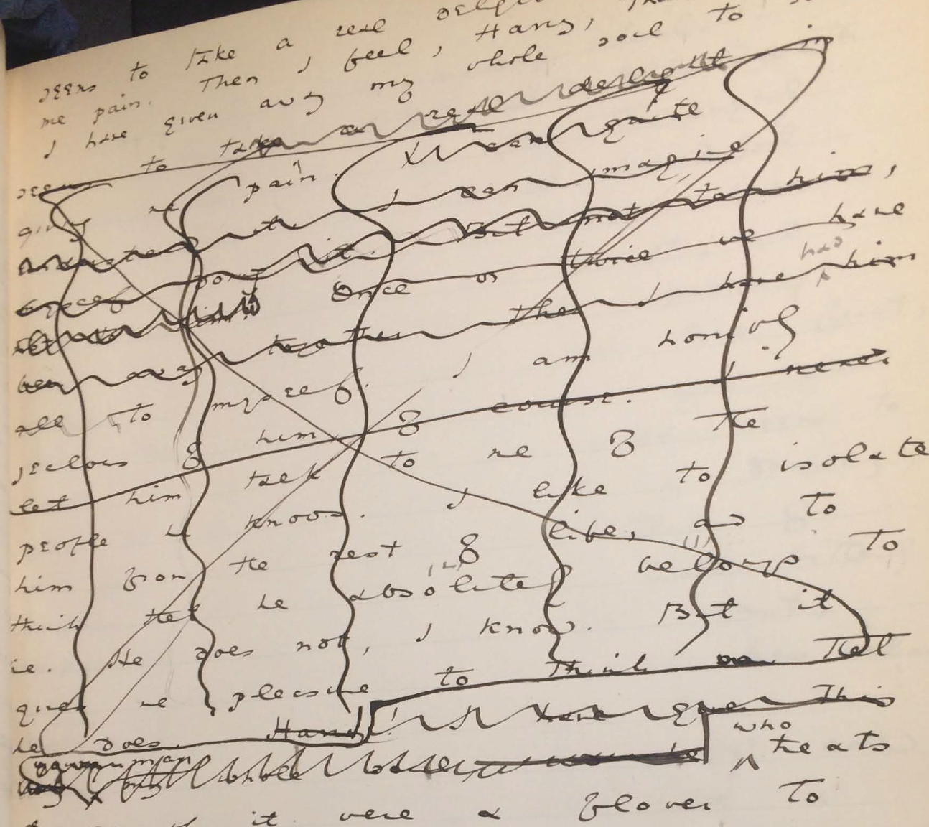F

igure 1: Image of the manuscript passage on MS 23 from The Morgan Library and Museum.

My final example concerns a longer passage (see Figs. 2 & 3) that was heavily revised in the manuscript. The treatment of this passage crystallizes the various patterns of revision seen so far—-removing signs of intimacy, diminishing tension in dialogue, references to Dorian's beauty and Basil's passion and fatality. The passage in the manuscript bears quoting in full. Prior to any revisions, it reads:

‘You remember that landscape of mine… It is one of the best things I have ever done. And why is it so? Because, while I was painting it, Dorian Gray sat beside me, and as he leaned across to look at it, his cheek just brushed my cheek. The world becomes young to me when I hold his hand, as when I ask him the [illegible].’

‘Basil, this is [illegible] you must not talk [illegible] [illegible] his power, [indecipherable] to make yourself the [illegible] slave! It is worse than wicked, it is silly. I hate Dorian Gray.’

Hallward got up from the seat, and walked up and down the garden. A curious smile curled his lips. He seemed like a man in a dream. After some time he came back. ‘You don’t understand, Harry…’ he said. ‘Dorian Gray is merely to me a motive in art. He is never more present in my work then when no image of him is there. He is simply a suggestion, as I have said, of a new manner. I see him in the curves of certain lines, in the loveliness and subtleties of certain colours. That is all.’

‘Then why won’t you exhibit his picture?’

‘Because I have put into it the romance of which I have never dared to speak to him. He knows nothing about it, but the world might guess it, where there is merely love, they would see something evil, where there is spectacular passion, they would suggest something vile.' MS 20-21

Many of these lines are crossed out, some so heavily, that entire phrases are illegible, as indicated by the tags. What remains legible, however, suffices to draw some conclusions about Wilde’s revision practice. In the first paragraph, the section from “and as he leaned across” to the end of the paragraph is crossed out in a likely attempt to remove evidence of physical intimacy (“his cheek just brushed my cheek”) and suggestions of romance (“the world becomes young to me when I hold his hand”). While some of this paragraph is legible, the next one, by contrast, is almost completely blotted out. From what I can gather, it consists mostly of Lord Henry’s condemnatory and jealous protestations–"his power," "to make yourself the… slave!" and "I hate Dorian Gray." In striking through these lines, Wilde obscures Lord Henry’s exasperation about Basil succumbing to Dorian’s charms. Most of the third paragraph eludes erasure, and is preserved in the manuscript: here, Basil finally explains the precise influence that Dorian has upon his art–as an ideal that inspires and stimulates beauty in the natural world. Subsequently, in the final paragraph, Wilde again obscures much of language, particularly this revelatory line: "where there is merely love, they would see something evil, where there is spectacular passion, they would suggest something vile." With this admission, Basil’s meaning throughout the passage attains clarity: Dorian Gray inspires a powerful, romantic attraction in Basil that suffuses all of his work with beauty and wonder.

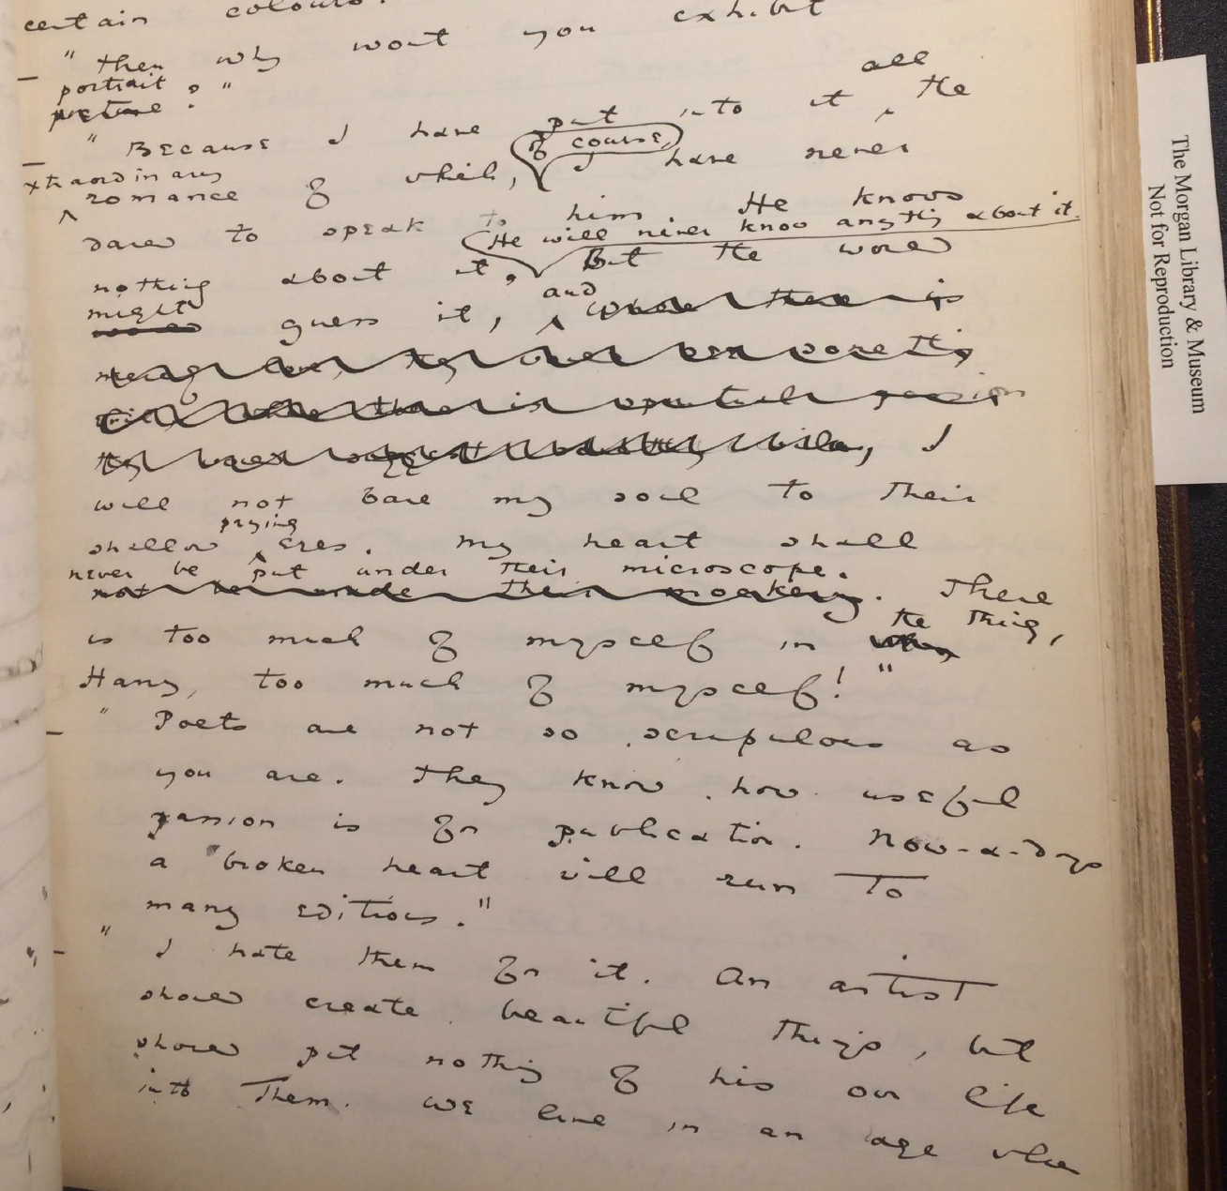Figure 2: Image of manuscript passage beginning on MS 20 from The Morgan Library and Museum.

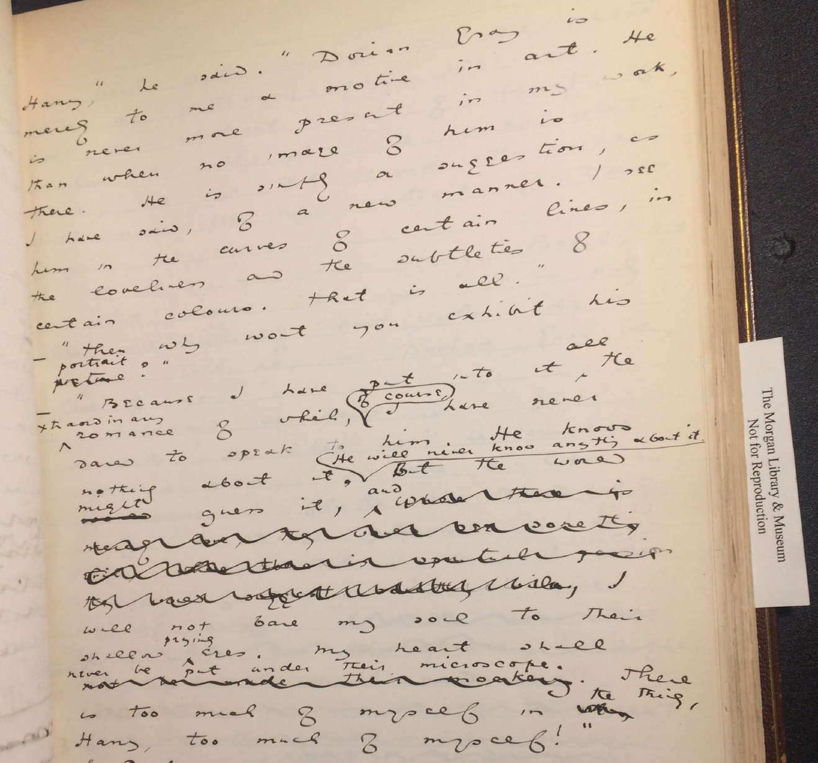

Figure 3: Image of manuscript passage ending on MS 21 from The Morgan Library and Museum.

One of the questions this paper poses is how Wilde’s treatment of homoerotic themes during the revision of the manuscript fits within the project of aestheticization as alleged by textual scholars like Donald Lawler, Joseph Bristow, and Nicolas Ruddick. In one of his letters to the St James Gazette, Wilde divulges what he calls the "moral" of the story: "all excess, as well as all renunciation, brings its own punishment" ("To the Editor of the St James Gazette," June 26 1890). The textual scholarship on Dorian Gray generally agrees that Wilde suppressed the moral by aestheticizing the text. Joseph Bristow argues that Wilde aimed to obscure the moral from the story’s early stages, when he was preparing it for publication in Lippincott’s: “In keeping with the manuscript, in the typescript Wilde proved reluctant… to preserve any statements that might lend unnecessary emphasis to what might be viewed as the implicit moral of the tale’” (xxxvii). Donald Lawler argues that subordination of the moral to aesthetic concerns extends to Wilde’s treatment of the homoerotic content in the story as it evolved from periodical to book version. He argues that Wilde cuts and revises this type of content for two reasons: first, to emphasize Dorian’s responsibility over his own degeneration, and second, to improve the quality of the writing. According to Lawler, “By Wilde’s shifting his emphasis in the Lippincott’s and in the Ward, Lock & Company Dorian Gray from homosexual passion to aesthetic interest, Basil’s culpability is Dorian’s fall from grace is muffled and reduced finally to that of the author of the detested painting” (26). The result of the revision is that Dorian becomes responsible for his own corruption, assuming the dramatic role as the fallen one. Lawler’s second explanation behind Wilde’s revisions concern style. Here, he argues that “in most cases the offensive passages shown above in the notes were cut because of their mawkish and sentimental writing as much for their affront to contemporary moral standards” (65). So, from this view, the homoerotic content was removed either to reduce Basil’s complicity in Dorian’s corruption or for the sake of style.

Nicolas Ruddick offers another perspective on Wilde’s treatment of the homosexual content as it relates to the moral. Examining the differences between the DG90 and DG91, Ruddick argues that DG90 is the “aesthetically superior” text, because it does a better job than DG91 maintaining a coherence between the story’s two morals. The two parables concern the dangers of vanity and the liberalization of homosexuality: while the overt parable “dramatize[s] the disastrous consequences of the preference of the beautiful at the expense of the good”, the covert parable, by contrast, “explores the destructive effects of the clandestine or closeted life” (126, 128). According to Ruddick, while DG90 creates a disjunction between what he calls the “overt” and “covert” parables, of the story, the revisions in DG91 fail to resolve this flaw. Ruddick contends that Wilde, in DG91, “chose the route of suppression,” reducing the homoerotic elements and including a preface defending art from the moral judgements of the bourgeois critic (133). Ruddick explains that the two parables appear to associate vanity and closeted homosexuality with corruption: “the appalling changes to Dorian’s painted image in DG90 strongly suggest that the unspeakable practices indulged in by the protagonist are unspeakable in themselves” (129). So, according to Ruddick, Wilde’s later story emphasizes a moral that warns against the dangers of vanity at the expense of one about the liberalization of homosexuality.

How does this debate play out in the first chapter of the manuscript? Together, the changes between the different textual witnesses suggest that Wilde had a deliberate purpose in revising the first chapter of the story. It appears that the revisions work to obscure or diminish the homosexual and homoerotic elements by turning Dorian into an aesthetic object. They achieve this goal in three ways: first, by removing the negative connotations of Basil’s attachment to Dorian, particularly the consuming intensity of his devotion; second, by easing the tension surrounding his dialogue with Lord Henry, sometimes lightening the heavier moments with a touch of comedy; and finally, by emphasizing Dorian as an ideal subject for art, expanding his appeal from the romantic and the physical toward a spiritual influence that inflects his surroundings. In these ways, the revisions turn something troubling and potentially fatal into a celebration of ideal beauty. This result also accords with Ruddick’s claim, that the revisions emphasize a moral that warns against the dangers of vanity at the expense of a moral about the liberalization of homosexuality. It seems that, by tempering Basil’s passion and aestheticizing Dorian, Wilde is able to remove the negative consequences of passion and replace them with the ones of worshipping beauty. However, while the earliest version of the story appears to associate homosexuality and vanity with corruption, it also warns against interpreting passion as a negative quality. Indeed, Basil makes precisely this argument when he explains to Lord Henry his reason for not exhibiting the portrait: “where there is merely love, they would see something evil, where there is spectacular passion, they would suggest something vile” (MS 21). This line, struck from the manuscript, leaves one with the suspicion that Wilde may have silenced the homosexual themes for the same reason that Basil could not exhibit his portrait.

## TEI

Now I will describe the electronic editing process for this text. I used a tool called TEI (short for Text Encoding Initiative), which is a method for encoding texts in such a way that humans and computers can make sense of them. In more technical terms, TEI is a "markup language," that enables users to "mark up" aspects of literary texts that they think are important, like structural elements (chapters, paragraphs, line breaks), physical details about the text (revisions, illegible text) or conceptual elements (like personages or places). TEI resembles HTML (HyperText Markup Language), which is another popular markup language, and indeed, both descend from the same parent language, SGML (Standard Generalized Markup Language). As "markup schemas," both TEI and HTML are annotations within a text that describe its structural, renditional, or conceptual elements. All texts are implicitly encoded (or marked up) in the sense of punctuation, capitalization, disposition of letters around the page, even the spaces between words.

TEI was created specifically for markup up literary material. It consists of a set of guidelines that facilitates electronic editing, digitization, and transcription of print text or manuscripts. Maintained by the TEI Consortium, the guidelines contains rules for using various "tags" to mark up certain textual elements, such as <line> to indicate a line of text, <del>, to indicate deleted text, and <person>, for a reference to a person. Below is an image of TEI text, in this case the manuscript from Mary Shelley's Frankenstein, digitized and encoded by the Shelley-Godwin Archive (see Fig. 4).

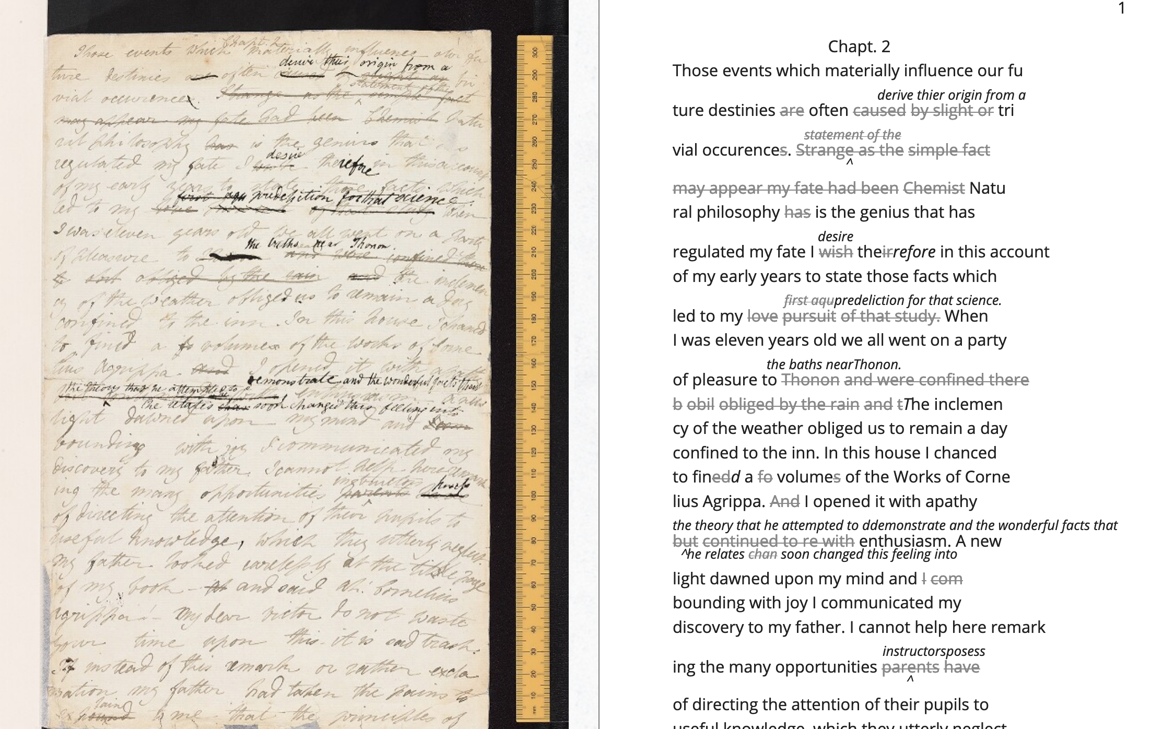

Fig 4: Image of the manuscript and diplomatic transcription of Frankenstein from the Shelley-Godwin Archive.

Here is an excerpt of some of the TEI code underlying this diplomatic transcription. Note that the first few lines of the text contained within the <line> tags, and the deleted text contained within <del> tags:

<handShift medium="pen" new="#mws"/>

<line>Those events which materially influence our fu</line>

<line>ture destinies <del rend="strikethrough">are</del> often

<mod>

<del rend="strikethrough">caused</del>

<del rend="strikethrough">by slight or</del>

<add hand="#pbs" place="superlinear">derive their origin from a</add>

</mod> tri </line>

<line>vial occurence

<del rend="strikethrough">s</del>.

<mod spanTo="#c56-0005.01"/>

<del rend="strikethrough" next="#c56-0005.02">Strange as the</del>

As one can see in the markup, TEI facilitates deep and complex description of textual material. TEI allows for textual elements to be searched, processed, and rendered to facilitate scholarly research. In the above example, this includes a diplomatic transcription of manuscript materials, with specific information about who is writing which portions of the text. The text is encoded according to the "hand," indicated by the <handShift> tag and @hand attribute, of either the main author Mary Shelley, who composed the text, or her husband, Percy Shelley, who edited. In line 8 of the above TEI excerpt, one can see that Percy Shelley makes an addition within the <add> tag.

Besides encoding text for diplomatic transcription, one can also encode text for references to persons or places. For example, The Willa Cather Archive describes in detail personal and geographical references within her correspondance. Below is an image (see Fig. 5) of an excerpt of a letter, which contain encoded references.[8]

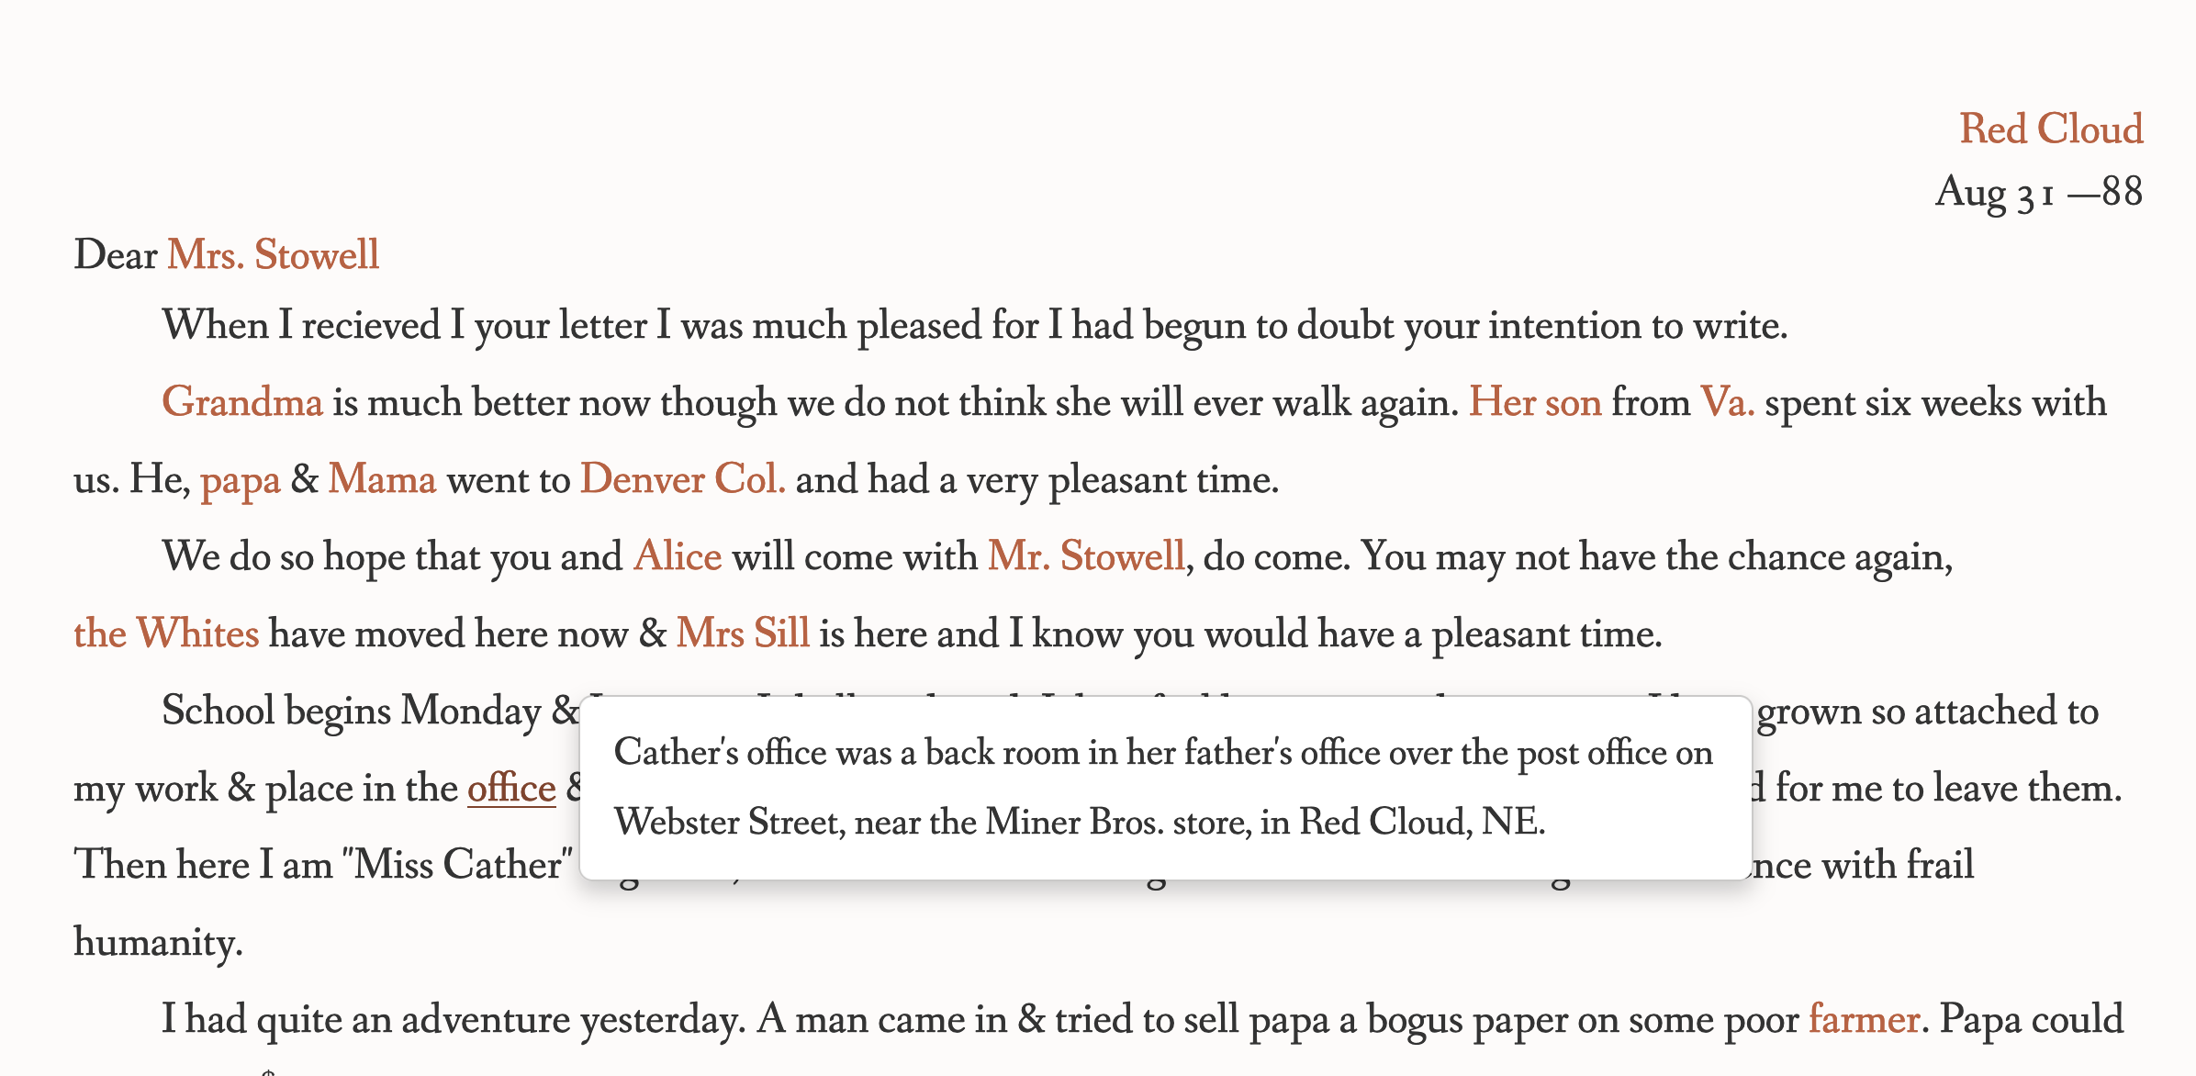Figure 5: Image of Cather's letter transcription from the Willa Cather Archive.

Similarly to the <handShift> tag in the Shelley-Godwin Archive, this project uses tagging to reference external entities. Each person or place is encoded with a <persName> or <placeName> element, which contains a unique identifier (the @target attribute) for each entity that points to the description of each entity in the textual apparatus.

<persName target="psn:0105">Grandma</persName> is much better now though we do not think she will ever walk again.

<persName target="psn:1277">Her son</persName> from

<placeName target="geo:0223">Va.</placeName> spent six weeks with us. He,

<persName target="psn:0180">papa</persName> &

<persName target="psn:0198">Mama</persName> went to

<placeName target="geo:0062">Denver Col.</placeName> and had a very pleasant time.

Perhaps the most useful aspect about TEI is its customizability. As an extension of XML, or eXtensible Markup Language, specifically made to render humanities textual data, TEI is further extensible. Users can create their own tags to fit specific needs. Before moving on to describe TEI customization, it bears reviewing some of the other qualities that TEI inherits from XML. XML documents resemble an ordered hierarchy or nested tree structure, with the one "root" component and several "branches" that divide into smaller components, which David J. Birnbaum describes as "nodes." Birnbaum uses the example of a book to explain the organization of an XML document, using the <book> element as the root nodes, which contains child nodes for title page, table of contents, chapters, and paragraph elements. These would be formalized into an XML data structure as the following:

<book>

<titlePage>

<tableofContents>

<chapter1>

<paragraph>

<paragraph>

…

<chapter2>

…

</book>

This hierarchical nature of the TEI means that all elements in the text must be contained within this bounded structure. All encoded data must conform to this structure of containment, where one cannot overlap elements, only nest them. Thus XML is described as "nested" or "well-formed." Notice in the below example, where the <emphasis> tags are contained within the <sentence> tags:

<sentence>This is <emphasis>bad</sentence>form.</emphasis> <sentence>This is <emphasis>good</emphasis>form.</sentence>

Though the strict tagging structure of TEI forces encoders to categorize or label textual elements in a way that resolves potential ambiguities, it also encourages them to address more fixed and disambiguated textual elements. The "eXtensible" in XML means that one may extend, or customize, tags that suit particular projects. The Women Writers Project, directed by Julia Flanders, adequately frames how TEI's inherent extensibility can handle textual ambiguity. According to the WWP:

Unlike many standardization efforts, the TEI … explicitly accommodat[es] variation and debate within its technical framework. The TEI Guidelines are designed to be both modular and customizable, so that specific projects can choose the relevant portions of the TEI and ignore the rest, and can also if necessary create extensions of the TEI language to describe facets of the text which the TEI does not yet address.

In other words, TEI is built from a language that allows its users, in turn, to build their own version of that language. As a result, there is potential for representing the elements necessary to a project by customizing these elements on a project-by-project basis.

In order to be standardizable and sustainable across a variety of contexts, TEI imposes a certain fixity on textual data. However, the enforcement of standards for encoding text has its drawbacks, in particular to encoding queer elements. As humanists well know, textual data is open to interpretation, and there are always elements that cannot be contained within rigid categories or delimitations. The TEI–both in its format and the content of the tags–especially struggles to register ambiguity in textual data.

The encoding of queer gender in TEI is one interesting case study. Julia Flanders explains that the <person> element, which describes persons referenced within a text is limited in the kind of information it can hold, such as one gender identity for each person. For scholars working to encode multiple or diverse sexual identities, this data structure creates obstacles. For example, Pamela Caughie and Sabine Meyer endeavor to encode gender identity in Lili Elbe's life narrative, Man Into Woman. Elbe, also known as the Danish artist Einer Wagner, undertook one of the first gender affirming surgeries in 1930. Caughie and Meyer explain that the TEI, which only allows one value for the attribute "sex," cannot adequately reflect the complex sexual oscillations within Elbe's story. The attempt to mark up Elbe's complex gender ontology brought Caughie and Meyer against the limitations of the TEI:

[T]he deeper we got into mark-up, the more evident it became that the categories and hierarchies available to us were inadequate for our task… to identify a male subject who at times presents himself as masquerading as a woman, at others as being inhabited by one, and who eventually becomes a woman, in a life history narrated retrospectively from the perspective of Lili Elbe. 231

For these scholars, the limitations of the TEI are instructive by forcing them to consider the ways that computation works on a deeper level to reify gender as essential. The fixity that the TEI imposes upon the textual subject brought out the ways that gender is situational and relational across this text.

Other scholars have used TEI's data structure to their advantage. While TEI is strict about what constitutes a person–as an entity with one sex, for example, it also enables an approach toward personhood as multiple. Marion Thain's work encoding the diaries of Michael Field may appear to grapple with the same problem that Caughie and Meyer encounter with Lili Elbe. Like Caughie and Meyer, Thain works with a complex writing subject, a late 19th century English lesbian couple, Katharine Bradley and Edith Cooper, who write collectively under the shared pen name, Michael Field. The name "Michael Field," therefore, is "a bipartite name, signifying the assumed names of two separate women, as well as appearing to signify one single male identity" (Thain 228). The TEI allows the encoding of multiple identities connected to the personages of Edith Cooper and Katharine Bradley. Thain explains that:

[T]he proliferation and slipperiness of names is no mere childish caprice but a core part of the articulation of queer: an unhinging of ‘given’ or apparently predetermined identity through a strategy that articulates identity as constantly shifting, constructed, and performative. Text encoding can, in a simple but powerful way, help us explore and map this crucial strand of queer identity construction across the diary. 233

Thain uses the <persName> tag to "render searchable words not in the text but intimately tied to it. This is not a small issue in a diary in which Katharine Bradley herself is referred to by more than 20 different names" (233). By encoding each identity to its proper person, either Cooper or Bradley, Thain can solve the problem of multiple identities through the TEI.

If both the Lili Elbe and Michael Field projects deal distinctly with queer identities, why do Caughie and Meyer struggle to encode Elbe's identity while Thain appears to succeed with Field? The answer is that Michael Fields's identity is multiple while Lili Elbe's is plural, and TEI works best when the data, like Fields's, is discrete. As Flanders points out, markup is a tool for naming, bounding, and containment. As such, it works best with information that can be separated into distinct components in tagging. It does not work well with smooth information, or ambiguous information, which can be categorized as partial or shared (Flanders, "Queer Encoding"). TEI can encode multiple identities or identities contained within certain entities, as long as these identities do not blend or overlap. The queerness of Michael Field's identity is that they "do not pretend to record the life of a single male, as two different hands record the experience of two clearly differentiated people" (Thain 229). Rather, this entity contains multitudes of distinct identities connected to either Cooper or Bradley. Elbe's identity, by contrast, is not multiple as much as it is plural, containing several identities whose relationship to each other is ambiguous or continually shifting within one entity. Elbe's relation to gender is a smooth one, best described qualitatively, as one that alternatively "masquerades" or "inhabits" simultaneous gender ontologies. While a queerness like Fields's might be delineated and contained, with each identity named, and linked, in Elbe there is a quality of blending which the markup, by its nature, means to separate and fix.

For Flanders, the ability for researchers to create their own custom tags, for example, allows them to "imagine descriptive systems for identity that would operate in specific contexts (rather than totalizing contexts)… with appropriate places for saying 'there is also something incontestable here'" ("Queer Encoding"). Opposing this view that TEI is flexible enough to engage queerness, scholars like Caughie and Meyer maintain TEI reinforces the fundamental elusiveness of mapping gender ontologies: "Data will always be contextual, limited, and only proximate to any individual identity" (238). So while TEI encourages the creation of customized tags, the potential for customization does not enable one to avoid the limitations of containment, in which all data must be rigidly demarcated within semantic tags. TEI bounds what it names in ways that preclude plural ontologies.

My customization of the TEI explores how the potential for new semantic labels engages with the fixed structure of TEI schema. I describe the changes to the manuscript using a custom set of tags that register both physical (pen strokes) and conceptual (homoerotic themes) elements of Wilde's revision. I created two new attributes to reflect Wilde's treatment of the homoerotic elements. Fist, to indicate sections of text that are struck out by Wilde's pen, I created the new attribute, "strokes," and set its value to a number. Most often, Wilde alternates using one or two or more strokes of his pen. Sometimes, however, the strokes are too heavy or thick to enumerate. For these, I used the value "inconclusive." For example, in the below image (Fig. 6), where Wilde revises the phrase "look of pain" to "expression of perplexity," Wilde's pen nearly blots out the word "look," while the word "pain" only has one stroke.

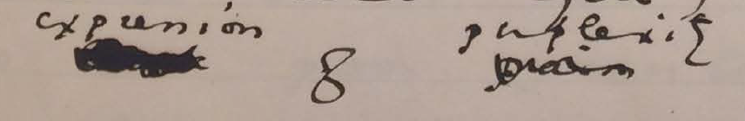Figure 6: Close-up image of detail on MS 9 from The Morgan Library and Museum.

In addition to strokes, I also created the new attribute, "implication," and set its value to a number of recurring themes from the deleted text. The themes are pulled from my close reading of the chapter revisions, and include: "tension," "intimacy," "affection," "beauty," "passion," and "fatality," with the additional values of "inconclusive" or "illegible" to describe ambiguous elements.

My customization creates a formalized method that allows me to mark the ways that homoeroticism has been elided or transformed as Wilde prepared the text for publication. That being said, formalization is not the goal of this particular project. Thinking back to Love's point that any attempt to affix queerness in the past "can only take place under the shadow of loss… [wherein] success would constitute failure," my goal is rather to use TEI to probe the limitation of such a formal method (51). My work in using the attributes surfaces the ways that Wilde's revisions constitute a spectrum of smooth information, with boundaries unamenable to demarcation, in which I have to make final, imposing decisions. For example, in the passage which contains the "look of pain" phrase, I am compelled to disambiguate the category of revision. Below is an image of the manuscript page (Fig. 7) and the TEI markup (Fig. 8).

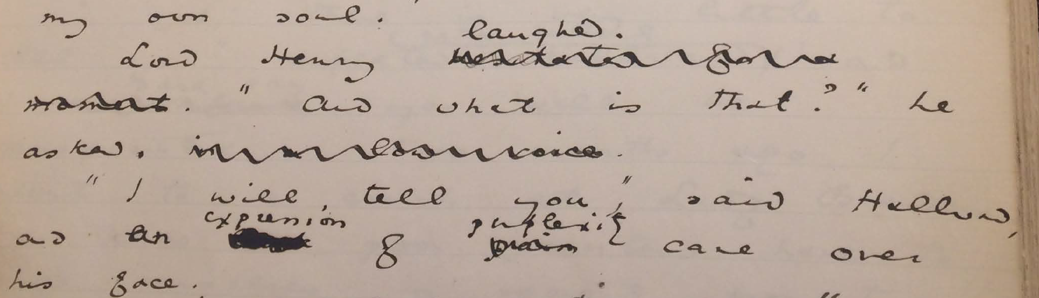Figure 7: Image of passage on MS 9 from the Morgan Library and Museum.

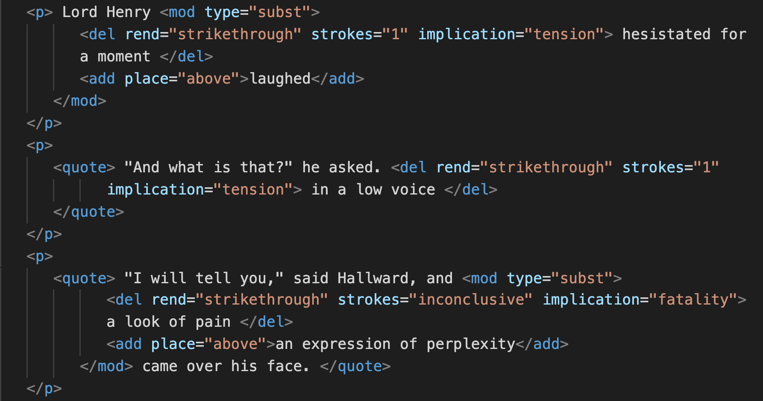Figure 8: Image of text encoding for MS 9.

When encoding this revision, I struggle to decide if the phrase "look of pain" expresses more a sense of passion or that of fatality. On the one hand, "pain" is a strong feeling, or passion, associated with desire. On the other hand, Basil often draws on pain in his references to the fatality of his attraction to Dorian, as in the following quote, which was deleted: "I feel, Harry, that I have given away my whole soul to someone seems to take a real delight in giving me pain" (MS 23). Adding another layer of complexity to this example, Wilde uses different kinds of strokes for the same phrase. With TEI, it is impossible to mark the variations in strokes without separating the single revision into two instances. Therefore, in marking the strokes, I opted to use the value "inconclusive."

More examples occur across the themes of intimacy and affection. In the below passage (see Fig 9), Wilde revises the phrase "and as he leaned across to look at it, his cheek just brushed my cheek" to "and as he leaned across to look at it, his hair just touched my hand" (MS 20). Due to its physical nature, I categorized this particular phrase as "affection." However, because it is part of a longer passage, I modified my label to "passion," which is a more general term that includes other revisions done in the same sentence, such as "The world becomes young to me when I hold his hand" (MS 20).

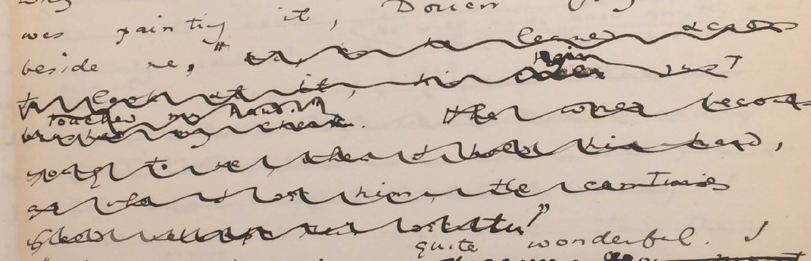Figure 9: detail on MS 20 from the Morgan Library and Museum.

To fix these ambiguities, I could tag them with both or even multiple values. But such tagging would dilute the analytical utility of the TEI, which is meant to be decisive rather than exhaustive. On the other hand, I could be even more specific, employing qualitative markers that are ever more precise, "tenderness" in addition to "affection," or "ardor" and "devotion," in addition to "passion," for example. However, the more specific the tags, the less possibility of finding connections between them, and the more demarcated the possibilities for analysis.

## Conclusion: Toward A Queer Form

My approach in customizing the TEI is to handle queer elements in a such way that engages the lessons from queer history. This approach attends to the slippery themes that elude containment, such as intimacy and affection, or passion and fatality. Heather Love's characterization of queerness as "always bound up with loss," enables textual scholars to accept that queerness is, like Eurydice, already turning backward (51). That the attempt to "rescue" or "recover" certain textual elements will only lead to inevitable failure. TEI in particular encourages the encoder to impose a level of fixity on text. Therefore, I have tried to tag the homoerotic elements in a way that enables them to retain some of their elusiveness, without attempting to pin down or transform their elusiveness into something more intelligible and palatable.

My question, moving forward, is how do we label something as fixed and at the same time maintain its fluidity? How might we approach tagging as a way of releasing textual meaning, rather than attempting to "recover" or "rescue" what is turning backward within the composition history? Drawing from Jerome McGann and Lisa Samuel's idea of deformance, we might look at the formalizations produced by this TEI schema not for what it reveals about Wilde's intentions, but for how it releases potential readings of the composition history. Such an approach would redeploy the categorization and labelling of markup toward speculative experimentation, exploring what Kadji Amin, Amber Jamilla Musser, and Roy Pérez describe as “queer form”— “the range of formal, aesthetic, and sensuous strategies that make difference a little less knowable, visible, and digestible.” Keeping a critical awareness of the TEI limitations, one might use the tool to mark and visualize queer form, particularly the elusive affects, repressed desires, and other coded elements of queerness within this text. When grappling with the strict structure of the TEI, running up against what can and cannot be encoded, one recognizes what escapes or eludes our structures for understanding and analysing queerness to rework those forms into new configurations.

# Works Cited

Amin, Kadji, Amber Jamilla Musser, and Roy Pérez “Queer Form: Aesthetics, Race, and the

Violences of the Social” ASAP/Journal, Volume 2, Number 2, May 2017, p. 235.

Barnett, Fiona, Zach Blas, Micha Cárdenas, Jacob Gaboury, Jessica Marie Johnson, and Margaret

Rhee, "QueerOS: A User’s Manual." Debates in the Digital Humanities, eds Matthew K. Gold and Lauren Klein. University of Minnesota Press. 2016.

Birnbaum, David J. “What is XML and Why Should Humanists Care?” Digital Humanities. 2021.

<http://dh.obdurodon.org/what-is-xml.xhtml>

Caughie, Pamela L., Emily Datskou, and Rebecca Parker. "Storm Clouds on the Horizon: Feminist

Ontologies and the Problem of Gender." Feminist Modernist Studies 1.3 (2018): 230-242.

Flanders, Julia. "Encoding Identity." Keynote, Queer Encoding: Encoding Diverse Identities, the

Digital Scholarship Center, Temple University. April 28, 2017.

Goldberg, Jonathan, and Madhavi Menon. “Queering History.” PMLA, vol. 120, no. 5, 2005, pp.

1608–1617.

Greg, Walter W. "The Rationale of Copy-Text," Studies in Bibliography Vol. 3, 1950/1951, pp. 19-

36.

Halperin, David M. "How to Do the History of Male Homosexuality." GLQ: A Journal of Lesbian

and Gay Studies, vol. 6 no. 1, 2000, p. 87-123.

Jewell, Andrew. The Willa Cather Archive. U of Nebraska-Lincoln, 2004-2013. Web. 13 Dec. 2012.

Lawler, Donald L. An Inquiry into Oscar Wilde's Revisions of the Picture of Dorian Gray. New

York, Garland Pub, 1988.

Leckie, Barbara. “The Novel and Censorship in Late-Victorian England.” The Oxford Handbook of

the Victorian Novel. Corby: Oxford University Press, 2013.

Love, Heather. Feeling Backward: Loss and the Politics of Queer History. Harvard University

Press, 2009.

McGann, Jerome. "Radiant Textuality: Literary Studies after the World Wide Web." Springer, 2016.

McKenzie, D.F. Bibliography and the Sociology of Texts. Cambridge University Press, 1999

Ruddick, Nicolas. “‘The Peculiar Quality of my Genius’: Degeneration, Decadence, and Dorian

Gray in 1890-1891.” Oscar Wilde: The Man, His Writings, and His World. ed. Robert N Keane. New York: AMS Press, 2003. pp.125-137.

The Shelley-Godwin Archive. University of Maryland, College Park. Maryland Institute for

Technology in the Humanities (MITH).

Tanselle, G. Thomas. "A Rationale of Textual Criticism." Publication of the ASW. 1992.

Thain, Marion, "Perspective: Digitizing the Diary - Experiments in Queer Encoding," Journal of

Victorian Culture, Volume 21, Issue 2, 1 June 2016, Pages 226–241.

“To the Editor of the St James Gazette,” 25 June 1890. Rpt. in Wilde, Oscar, and Michael Patrick

Gillespie. The Picture of Dorian Gray: Authoritative Texts, Backgrounds, Reviews and Reactions, Criticism. 2nd ed. ed., New York, W.W. Norton, 2007. pp. 355-356.

Traub, Valerie. “The New Unhistoricism in Queer Studies.” PMLA, vol. 128, no. 1, 2013, pp. 21–39

Wilde, Oscar. The Picture of Dorian Gray: Original Manuscript. 1889–90. MS. Morgan Library &

Museum, New York, NY.

Wilde, Oscar, and Joseph Bristow. The Complete Works of Oscar Wilde. Vol. 3. Oxford, Oxford

University Press, 2000.

Wilde, Oscar and Nicholas Frankel. The Picture of Dorian Gray: An Annotated, Uncensored

Edition. Harvard University Press. 2011.

Wilde, Oscar, and Michael Patrick Gillespie. The Picture of Dorian Gray: Authoritative Texts,

Backgrounds, Reviews and Reactions, Criticism. 2nd ed. ed., New York, W.W. Norton, 2007.

1. See Barnett, Fiona, Zach Blas, Micha Cárdenas, Jacob Gaboury, Jessica Marie Johnson, and Margaret Rhee. "QueerOS: A User’s Manual" Debates in the Digital Humanities 2016.
2. See Gaboury, Jacob. "Becoming NULL: Queer relations in the excluded middle." Women & Performance: a journal of feminist theory 28.2 (2018): 143-158.
3. See Traub, Valerie. “The New Unhistoricism in Queer Studies.” PMLA, vol. 128, no. 1, 2013, pp. 21–39; and Halperin, David M. "How to Do the History of Male Homosexuality." GLQ: A Journal of Lesbian and Gay Studies, vol. 6 no. 1, 2000, p. 87-123.
4. See Goldberg, Jonathan, and Madhavi Menon. “Queering History.” PMLA, vol. 120, no. 5, 2005, pp. 1608–1617; and Freccero, Carla, et al. “Historicism and Unhistoricism in Queer Studies.” PMLA, vol. 128, no. 3, 2013, pp. 781–786.
5. Orpheus seeks to rescue Eurydice from Hades, the lord of the Underworld, on the condition that he does not turn around to look back at her until they exit the Underworld and re-emerge into the sunlight. Unable to restrain himself, Orpheus turns back to gaze at Eurydice just as they are about to pass through the threshold. He manages to catch a glimpse of his lover, but she is already turning away, into the interminable darkness where she will be forever imprisoned.
6. Though this paper considers some of Stoddart’s editorial influence on the typescript, see pp. 40-54 in Nicolas Frankel's The Picture of Dorian Gray: An Annotated, Uncensored Edition for a more complete accounting of his role in preparing the typescript for publication. Frankel's edition attempts to reinstate Wilde’s original intentions in the typescript, "representing the novel as Wilde envisioned it in the spring of 1890, before Stoddart began to work his way through the typescript with his pencil and before Wilde’s later self-censorship of the novel" (21).
7. See the Norton Critical Edition of The Picture of Dorian Gray, ed. Michael Patrick Gillespie, for a selected list of full-length reviews from The Scots Observer, The St James Gazette and the Daily Chronicle, and Wilde’s responses.
8. Willa Cather to Helen Louise Stevens Stowell, August 31, 1888. <https://cather.unl.edu/writings/letters/let0001>